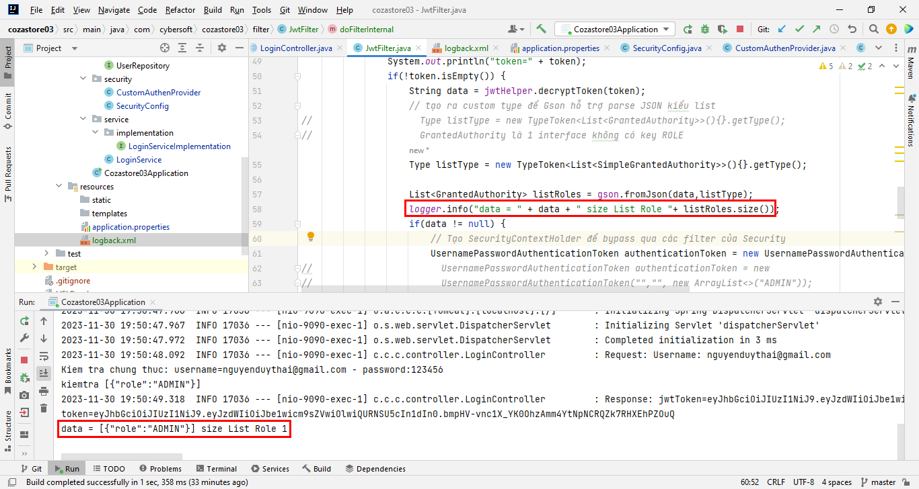

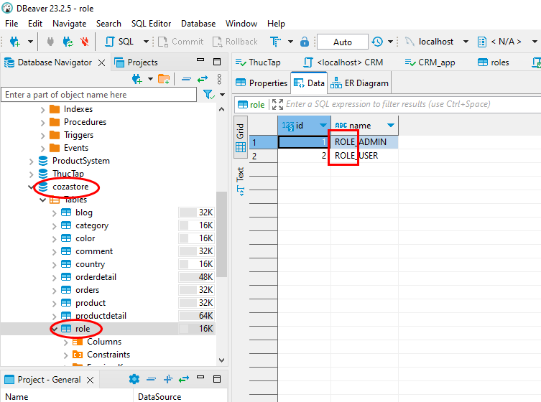

Lỗi Permission deny 403

UsernamePasswordAuthenticationToken authenticationToken = new UsernamePasswordAuthenticationToken("","", new ArrayList<>()); WRONG

UsernamePasswordAuthenticationToken authenticationToken = new UsernamePasswordAuthenticationToken("","", listRoles); RIGHT

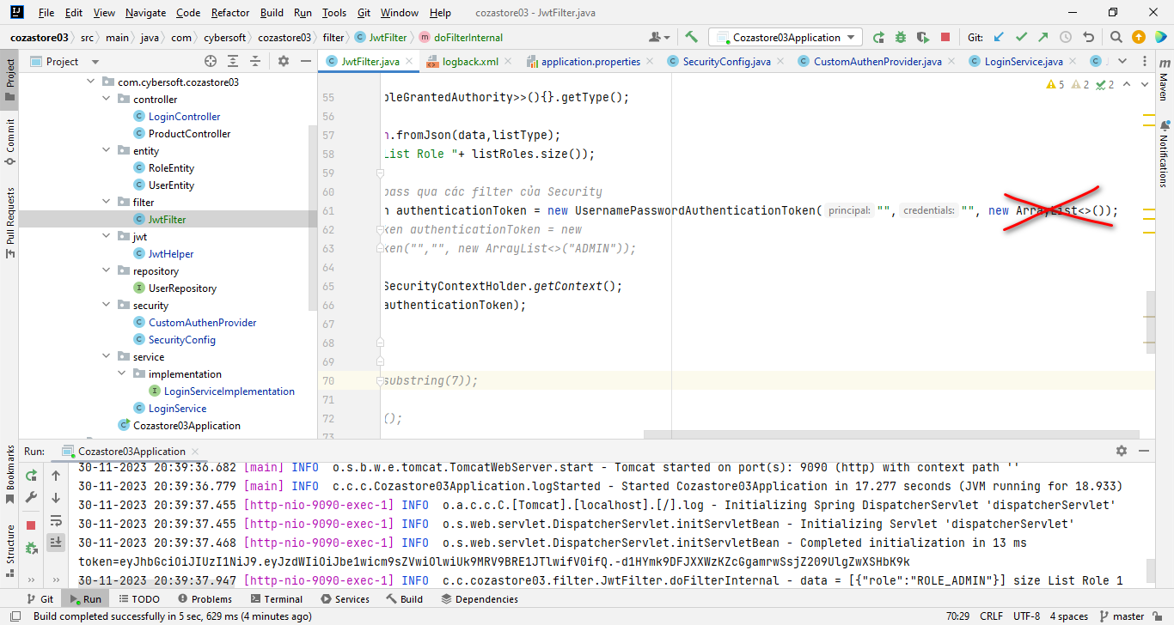

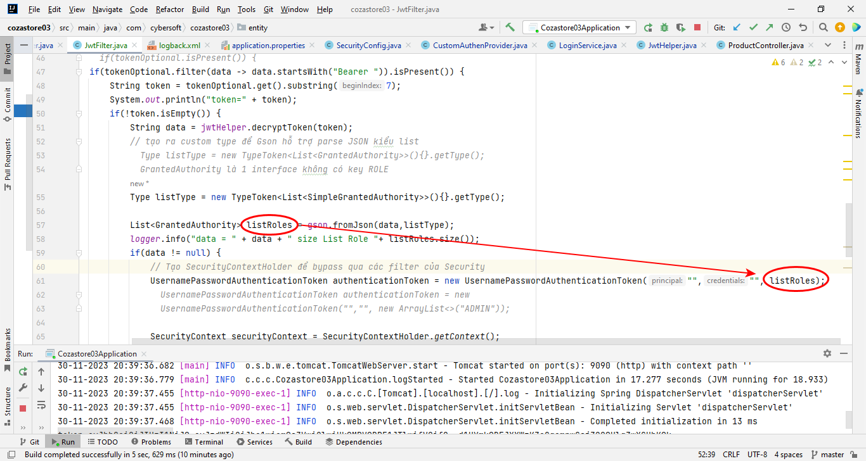

return new ResponseEntity<>( jwtToken, HttpStatus.*OK*); WRONG

return new ResponseEntity<>(baseResponse, HttpStatus.*OK*); RIGHT

